SMA Strategy Definition - Answer with Explanation
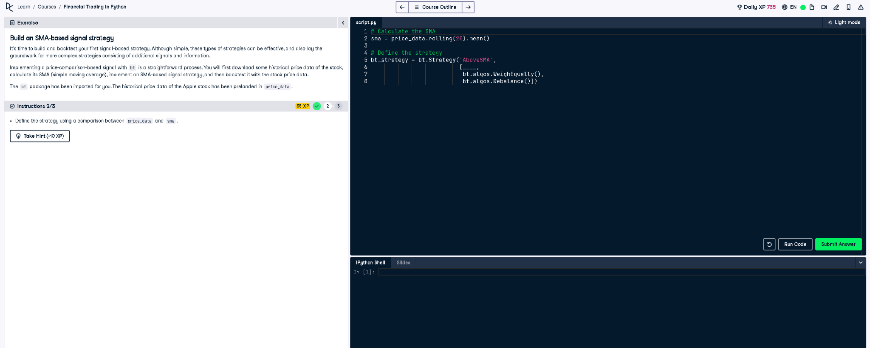

✅ Full Python Answer
# Calculate the SMA (Simple Moving Average)
sma = price_data.rolling(20).mean()
# Define the strategy
bt_strategy = bt.Strategy('AboveSMA',
[
bt.algos.SelectWhere(price_data > sma),
bt.algos.WeighEqually(),
bt.algos.Rebalance()
])

✅ Explanation in Simple Words (50 words)
This strategy buys the asset only when its current price is above the 20-day moving average (SMA). It compares each value in price_data to the SMA. If the price is higher, it triggers a buy. This approach aims to capture upward trends and avoid sideways or falling markets.

